UML Activity Diagram

The uml activity diagram starts off with verifying the users pin number. If the entered pin is incorrect the trans action is automatically ended. If the pin entered is correct the system will ask the user how much they wish to withdraw. If the amount is not available the system will generate a receipt, then print the receipt then end the transaction. If the amount is available the system will dispense the cash, then generate the receipt then print, sifter that the transaction e=will be ended. I think this atm should have an option to check balances to make it a fully functioning atm.

UML Sequence Diagram

To start out the user enters the card into the atm, the atm asks for a pin, the user then enters the pin, at that time the atm will verify the pin with the bank, if the pin is valid the atm will ask the user for the amount wanted, once the user enters an amount the atm will dispense the cash. This diagram does not have an action to perform if the entered pin is incorrect. It should also be able to allow the user to check balances. And after the transaction is complete it should ask the user if there is anything else they would like to do or if u=the user wants to end the transaction. This diagram also does not have an action set for if the amount requested is not available.

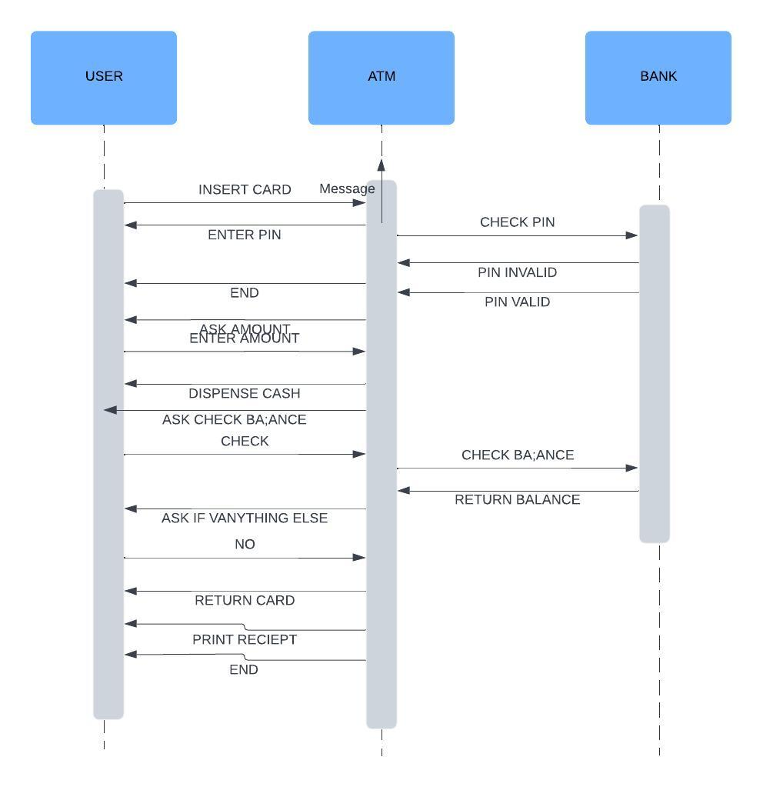

I reconstructed the uml sequence diagram, I added the function to cancel and to end the transaction if the pin is incorrect, a wat to check balance and a function to return the users card also I added a way to print receipt